

Department of Computer Science and Software Engineering

INTERNATIONAL ISLAMIC UNIVERSITY ISLAMABAD

Semester Spring 2024

**Lab Report 2**

Operating System

Date: 13 Mar, 2024

Submitted by:

**OSAMA MALIK**

4319-FCIT/BSSE/F21

Submitted to:

**Mr. Niaz Muhammad**

**Linux Commands**

1. **abc.txt|wc**

**Description of Command:** This command is used to count the number of lines, words, and characters in the "abc.txt" file.

**Purpose:** Counting the lines, words, and characters in the file "abc.txt".

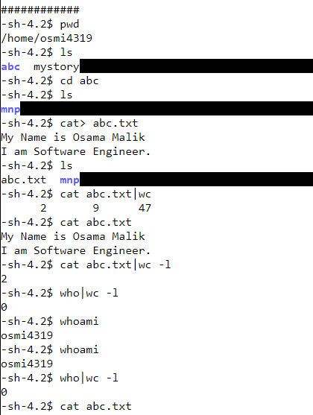

1. **abc.txt|wc -l**

**Description of Command:** This command is used to count the number of lines in the "abc.txt" file.

**Purpose:** Counting the number of lines in the file "abc.txt".



1. **who|wc -l**

**Description of Command:** This command is used to count the number of lines produced by the who command, which lists the currently logged-in users.

**Purpose:** Counting the number of logged-in users.



1. **cat .txt|wc**

**Description of Command:** This command is used to count the number of lines, words, and characters in all files with a ".txt" extension.

**Purpose:** Counting lines, words, and characters in multiple text files.

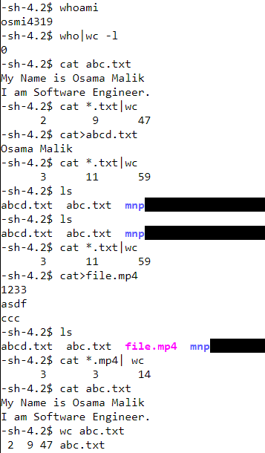

1. **cat *.mp4| wc**

**Description of Command:** This command is used to count the number of lines, words, and characters in all files with a ".mp4" extension like we have here file.mp4.

**Purpose:** Counting lines, words, and characters in multiple video files (though this command might not be meaningful for binary files like videos).



1. **wc abc.txt**

**Description of Command:** This command is used to count the number of lines, words, and characters in the "abc.txt" file.

**Purpose:** Counting lines, words, and characters in the file "abc.txt".

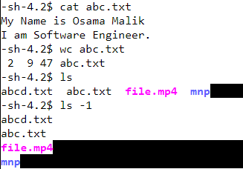

1. **ls -1**

**Description of Command:** This command is used to list files and directories in the current directory, with each entry on a separate line.

**Purpose:** Listing files and directories in a single column.



1. **ls -1 abc.txt mp4.txt**

**Description of Command:** This command is used to list the "abc.txt" and "file.mp4" files in the current directory, each on a separate line.

**Purpose:** Listing specific files in a single column.

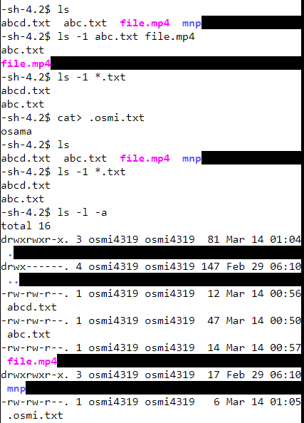

1. **ls -1 .txt**

**Description of Command:** This command is used to list all files with a ".txt" extension in the current directory, each on a separate line.

**Purpose:** Listing text files in a single column.



1. **ls -l -a**

**Description of Command:** This command is used to list files and directories in the current directory in long format, including hidden files.

**Purpose:** Detailed listing of all files and directories, including hidden ones.



1. **ls -la**

**Description of Command:** This command is used to list files and directories in the current directory in long format, including hidden files.

**Purpose:** Detailed listing of all files and directories, including hidden ones.

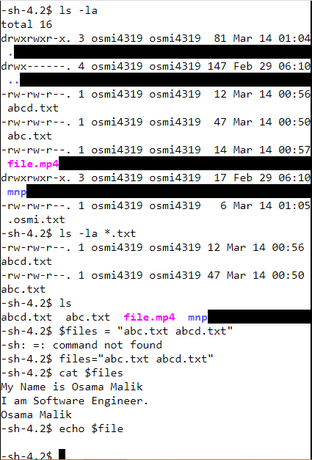

1. **ls -la .txt**

**Description of Command:** This command is used to list all files with a ".txt" extension in the current directory in long format, including hidden files.

**Purpose:** Detailed listing of text files, including hidden ones.



1. **files = "abc.txt H-lctxt"**

**Description of Command:** This command creates a variable named $files containing the filenames "abc.txt" and "H-lctxt".

**Purpose:** Storing file names in a variable for later use.



1. **cat $files**

**Description of Command:** This command is used to display the contents of files stored in the variable $files.

**Purpose:** Displaying the contents of specified files.



1. **echo $file**

**Description:** This command prints the value stored in the $file variable.

**Purpose:** To display the value stored in a variable.



******* End *******